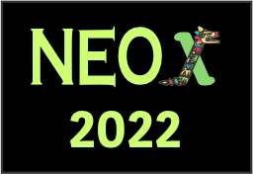
You may use this inscription form to sign in multiple attendees. In that case, make sure you provide names
and email addresses (for the login) and titles and author lists of the talks (for the login) and titles and
author lists of the talks use one inscription form per "factura" (only needed for participants living in Mexico)
LIGHT REGISTRATION
Attendance of the NEO 2020. For the presentation of a contributed talk a full registration is required
Number of light registrations:
PERS. 1 Name/e-mail/Institution:
PERS. 2 Name/e-mail/Institution:
PERS. 3 Name/e-mail/Institution:
PERS. 4 Name/e-mail/Institution:
PERS. 5 Name/e-mail/Institution:
FULL REGISTRATION
Number of full registrations:
PERS. 1 Name/e-mail/Institution:
PERS. 2 Name/e-mail/Institution:
PERS. 3 Name/e-mail/Institution:
PERS. 4 Name/e-mail/Institution:
PERS. 5 Name/e-mail/Institution:
Title and author list of the presented works:
FACTURA
(A "factura" is a particular invoice that will be only needed for participants living in Mexico. Note that in case a "factura"
is needed, the total amount will be increased by 16 percent.)
Will you need a "factura"? yes / no
If you need a "factura", please provide the required details.
Name:
R.F.C.
Adress:
e-mail
In case no "factura" is needed, a certificate of payment will be sent. If particular information should be provided on this
certificate, please specify:
EXTRAS
In case you need space to add more information, use this part.

